Mixing audio
Up until this point, we have not really concerned ourselves with the multichannel aspects of audio streams. That is, with few exceptions, we simply note that nodes are connected to nodes or audio parameters, and the audio streams are processed appropriately regardless of the number of channels in the stream.
But the Web Audio API offers tremendous support for multichannel audio. Multichannel formats are converted seamlessly, behind-the-scenes when needed. The developer may also specify how a node will handle the multichannel aspects of audio streams. And two nodes are provided to either merge audio streams into a single multichannel stream, or split a multichannel stream into many single channel streams.
The Chapter begins by explaining how the Web Audio API specifies the multichannel behavior of any audio node, including the use of multichannel mixing rules. The ChannelMergerNode and ChannelSplitterNode are then described. Finally, two code examples are provided. The first shows how to flip the channels in a stereo audio stream. The second example is a ping-pong delay, showing how a delay effect can 'bounce' delayed copies of a signal between left and right channels of an output audio stream.

Up-mixing and down-mixing
Up-mixing is the process of taking a source with a smaller number of channels and converting it to a source with a larger number of channels, and down-mixing is the process of taking a source with a larger number of channels and converting it to a source with a smaller number of channels.
All the sources connected to an input need to be mixed together. As part of this process, an AudioNode computes the actual number of input channels at any given time. It then has mixing rules for up-mixing or down-mixing the source to the correct number of channels, and then combining all these input sources. This last step is a straight-forward summing together of each of the corresponding channels that have been up-mixed or down-mixed for each connection.
For example, if a mono source and a stereo source are connected to an audio node that accepts only one single channel input, then the stereo source will first be down-mixed to mono before being summed with the mono source and this mix treated as the input to the node.

Computing the number of channels
To handle upmixing and downmixing, there are three interrelated AudioNode properties; channelCount, channelCountMode, and channelInterpretation.
All nodes have those attributes, which may be adjustable depending on the type of node. Together, these properties determine how inputs to a node are to be mixed.
channelCount gives the number of channels used when up-mixing and down-mixing connections to any inputs to the node. The default value is 2 except for specific nodes where its value is specially determined. This attribute has no effect for nodes with no inputs.
channelCountMode determines how channels will be counted when up-mixing and down-mixing connections to any inputs to the node. It can be ‘max’ (default), ‘clamped-max’ or ‘explicit’. It determines the computed number of channels N that controls how inputs to a node are to be mixed.
- 'explicit': N is the exact value specified by the channelCount.
- 'max': (default) N is the maximum of the number of channels of all connections to an input. In this mode channelCount is ignored.
- 'clamped-max': N is the maximum of the number of channels of all connections to an input, clamped to the given channelCount.
channelInterpretation determines how individual channels will be treated when up-mixing and down-mixing connections to any inputs to the node.
- 'discrete' maps each input channel to each output channel. Up-mix by leaving extra channels silent. Down-mix by dropping remaining channels
- 'speakers' (default) use up-mix and down-mix equations defined for specific channel layouts, e.g. mono (one channel), stereo (two channels), quad (four channels), and 5.1 (six channels). Where the number of channels do not match any of these basic speaker layouts, it reverts to 'discrete'.
Some nodes have additional constraints on the possible values for these options (see the Web Audio API specification).
Lets look at a few examples to make this clear.
Suppose we want to force all inputs to a node to be treated as stereo using the up-mixing and down-mixing rules. Since the mixing rules are applied, we will set channelInterpretation to ‘speakers’. Since we want stereo input in all cases, channelCount is set to 2 and channelCountMode is ‘explicit’. So we would have;
node.channelCount = 2;
node.channelCountMode = 'explicit';
node.channelInterpretation = 'speakers';

What if we do not want to apply mixing rules at all, we just want the node to see the first channel of every source, say for an AnalyserNode where we are interested in analysing just one channel. The AnalyserNode’s default settings are;
node.channelCount = 2;
node.channelCountMode = 'max';
node.channelInterpretation = 'speakers';

So we should change the channelCount to 1 and channelInterpretation to ‘discrete’ so that just the first channel of a source is used for the input.
node.channelCount = 1;
node.channelCountMode = 'explicit';
node.channelInterpretation = 'discrete';

Several types of nodes (Convolver, DynamicsCompressor, Panner and StereoPanner) all use the following configuration;
node.channelCount = 2;
node.channelCountMode = 'clamped-max';
node.channelInterpretation = 'speakers';

The idea is that, if at least one input has two or more channels, then it is all treated as two channel and the node does stereo processing. But if all inputs are single channel then there is no up-mixing and it does mono processing.
What if the output is going to some multichannel speaker array, where the user has specified the number of speakers. Here, we change these properties for the audio context’s destination.
context.destination.channelCount = numberOfSpeakers;
context.destination.channelCountMode = 'explicit';
context.destination.channelInterpretation = 'discrete';

Up-mixing and down-mixing rules
Channel ordering is defined by the following table. So for 5.1 multichannel sound for example, channel 3 of the audio stream always represents the front center channel and channel 4 represents the low frequency channel. Individual multichannel formats may not support all intermediate channels.
Speaker Layout | Channels
 | 0 | 1 | 2 | 3 | 4 | 5
Mono | Center
Stereo | Left | Right
Quad | Front left | Front right | Back left | Back right
5.1 | Front left | Front right | Front center | Low frequency | Surround left | Surround right

Up-mixing involves converting an audio stream with a smaller number of channels into one with a larger number of channels. For example, if an audio node has two input streams connected to one input, they will be summed together. If one of the input streams is mono and the other is stereo, then the mono stream will be up-mixed to stereo. Suppose we label the channels of a stream before up-mixing as x₀, x₁, … and the channels after up-mixing as y₀, y₁, … Then the up-mixing rules are given as shown in Table 15.A.
Up-mix type | Notation | Description | Output
 |  |  | y₀ | y₁ | y₂ | y₃ | y₄ | y₅
Mono | 12 | Mono to Stereo | x₀ | x₀
 | 14 | Mono to Quad | x₀ | x₀ | 0 | 0
 | 15.1 | Mono to 5.1 | x₀ | x₀ | 0 | 0 | 0 | 0
Stereo up-mix | 24 | Stereo to Quad | x₀ | x₁ | 0 | 0
 | 25.1 | Stereo to 5.1 | x₀ | x₁ | 0 | 0 | 0 | 0
Quad up-mix | 45.1 | Quad to 5.1 | x₀ | x₁ | 0 | 0 | x₂ | x₃
Table 15.A. Up-mixing rules for converting an audio stream x to an audio stream y with more channels, assuming channelInterpretation is 'speakers'.
Down-mixing involves converting an audio stream from a larger to a smaller number of channels. It is quite a common operation. For instance, many nodes default to stereo, but one often wants to work with a single channel. A down-mix could also be necessary when rendering for a format with less channels, for example, if processing 5.1 source material but playing back stereo. Various down-mixing operations are given in Table 15.B.
Down-mix type | Notation | Description | Output
 |  |  | y₀ | y₁ | y₂ | y₃
Mono | 21 | Stereo to Mono | (x₀+ x₁)/2
 | 41 | Quad to Mono | (x₀+ x₁+ x₂+ x₃)/2
 | 5.11 | 5.1 to Mono | (x₀+ x₁)/$\sqrt{2}$+x₂+(x₄+x₅)/2
Stereo down-mix | 42 | Quad to Stereo | (x₀+ x₂)/2 | (x₁+ x₃)/2
 | 5.12 | 5.1 to Stereo | x₀+ (x₂ + x₄)/$\sqrt{2}$ | x₁+(x₂+ x₅)/$\sqrt{2}$
Quad down-mix | 5.14 | 5.1 to Quad | x₀+ x₃/$\sqrt{2}$ | x₁+ x₂/$\sqrt{2}$ | x₄ | x₅
Table 15.B. Down-mixing rules for converting an audio stream x to an audio stream y with less channels, assuming channelInterpretation is 'speakers'.
So, for example, the AnalyserNode computes the time domain data by down-mixing to mono as if channelCount is 1, channelCountMode is 'max' and channelInterpretation is 'speakers', regardless of the settings for the AnalyserNode itself. Hence, if the input is 6 channel, x₀, x₁, … x₅, the time domain data is computed as
(x₀+x₁)/$\sqrt{2}$+x₂+(x₄+x₅)/2
Finally, note that these up-mixing and down-mixing rules do not always behave nicely. For instance, if one up-mixes a mono signal to stereo and then down-mixes it back to mono, one gets back the original signal. But if one up-mixes a stereo signal to quad and then down-mixes back to stereo, the resultant signal is half the amplitude of the original. Luckily, in most cases these subtleties do not matter. When working with multichannel audio, one needs to be aware of how the channels are interpreted and mixed. But generally, a different number of channels more than once.

Channel Merger
The ChannelMergerNode combines channels from multiple input audio streams into a single, multichannel output audio stream, as shown on the left in Figure 15.1. It is useful when one wants to render content for different spatial audio formats, especially when there are multiple sources that may have different spatial positions.
The ChannelMergerNode can also be used to arrange multiple audio streams in a certain order for the multi-channel speaker array such as 5.1 surround sound. The merger does not interpret the channel identities (such as left, right, low frequency etc.), but simply combines channels in the order that they are input.
It is often used in conjunction with its opposite, ChannelSplitterNode,
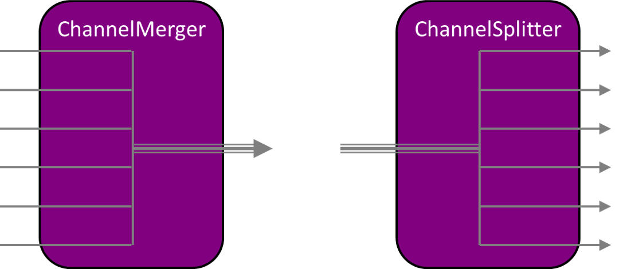
Figure 15.1. The ChannelMergerNode (left) and ChannelSplitterNode (right).
The ChannelMergerNode has a variable number of inputs (default 6), defined by the parameter numberOfInputs, but not all of them need be connected. There is a single output stream which has the same number of channels as the number of inputs when any of the inputs is actively processing. If none of the input streams are actively processing, then output is a single channel of silence.
To merge multiple inputs into one stream, each input gets downmixed into one channel (mono) based on the specified mixing rule. An unconnected input still counts as one silent channel in the output. Changing the input streams will not affect the order of output channels.
For example, if a default ChannelMergerNode has two connected stereo inputs, the first and second input will be downmixed to mono respectively before merging. The output will be a 6-channel stream whose first two channels are filled with the first two (downmixed) inputs and the rest of channels will be silent.
Using a ChannelMergerNode, it is possible to create outputs with more channels than the rendering hardware is able to process. In that case, when the signal is sent to the AudioContext’s destination, the extra channels will be ignored.

Channel Splitter
The ChannelSplitterNode is shown on the left in Figure 15.1. It is used to access the channels of a single input audio stream, and separate them into individual mono output streams that can be processed separately. It is useful when one wants to access or process each channel separately., e.g. to perform channel mixing where gain must be separately controlled on each channel. It is often used in conjunction with its opposite, ChannelMergerNode.
The node has one parameter, numberOfOutputs , with a default of 6, which determines the number of output signals (streams). The number of active outputs equals the number of channels in the input stream. Any outputs which are not active will output silence and would typically not be connected to anything.
For example, if a stereo input is connected to a ChannelSplitterNode then the number of active outputs will be two (one from the left channel and one from the right). The node does not interpret the channel identities (such as left, right, etc.), but simply produces output streams in the order that the channels occurred in the input.
One application for ChannelSplitterNode is for doing matrix mixing where individual gain control of each channel is desired.

Example: Channel Flipper
<button id='Flip'>Flip</button>
<script>
var flipped=false
var context = new AudioContext()
var monoSource = new OscillatorNode(context,{frequency:200})
var stereoSource = context.createChannelMerger(2)
monoSource.connect(stereoSource, 0, 0)//source0 goes to input 0 of stereoSource
monoSource.start()
var splitter = context.createChannelSplitter(2)
var flipper = context.createChannelMerger(2)
Flip.onclick= function() {
context.resume()
stereoSource.disconnect()
if (flipped) {
stereoSource.connect(context.destination)
flipped=false
} else {
stereoSource.connect(splitter)
splitter.connect(flipper, 0, 1)
splitter.connect(flipper, 1, 0)
flipper.connect(context.destination)
flipped=true
}
}
</script>

Code example 15.1. ChannelFlip.html, showing how the ChannelSplitter and ChannelMerger may be used to switch left and right channels in a stereo source.
Code example 15.1 shows usage of a ChannelSplitter and ChannelMerger to switch left and right channels in a stereo signal. We first create a stereo source using channel merger to put an oscillator in the left channel and leaving the right channel silent. Then each time the Flip button is pressed, left and right channels are switched using the following operations. First, the output of stereoSource is disconnected from any inputs.
If the Boolean flipped is true, then we simply connect it to the destination and set flipped to false.
If flipped is false, then we ‘flip it’ by connecting the stereoSource to the splitter. The splitter produces two output streams, each one containing a single channel. Flipping the two channels is accomplished by the following two lines;
splitter.connect(flipper, 0, 1)
splitter.connect(flipper, 1, 0)
In the first line, the first output stream of the splitter is connected to the second input stream of the ChannelMergerNode called flipper. Then, the second output stream of the splitter is connected to the first input steam of flipper.
The flipper now produces a single stereo output stream whose left channel is the right channel of the stereoSource and whose right channel is the left channel of the stereoSource. The left and right channels are now switched, so flipped is set to true.
A block diagram showing the connections when flipped is given in Figure 15.2.
Figure 15.2. Block diagram of the flipper when set to flip the left and right channels..

Note that each time we create a ChannelSplitter we specify the number of output streams, and each time we create a ChannelMerger we specify the number of input streams. This was not necessary though, since the default value in each case (6) is greater than the required two streams. Also note that when connecting the Splitter to the Merger, we needed to specify which of the two outputs of the splitter connects to which of the two inputs of the Merger. For most connections on most nodes, this isn’t done since one typically works with a single stream.
Code example 1 shows usage of a ChannelSplitter and ChannelMerger to switch left and right channels in a stereo signal. We first create a stereo source using channel merger to put an oscillator in the left channel and leaving the right channel silent. Then each time the Flip button is pressed, left and right channels are switched using the following operations. First, the output of stereoSource is disconnected from any inputs.
If the Boolean flipped is true, then we simply connect it to the destination and set flipped to false.
If flipped is false, then we ‘flip it’ by connecting the stereoSource to the splitter. The splitter produces two output streams, each one containing a single channel. The first output stream of the splitter is connected to the second input stream of the ChannelMergerNode called flipper. The second output stream of the splitter is connected to the first input steam of flipper. The flipper now produces a single stereo output stream whose left channel is the right channel of the stereoSource and whose right channel is the left channel of the stereoSource. The left and right channels are now switched, so flipped is set to true.
Note that each time we create a ChannelSplitter we specify the number of output streams, and each time we create a ChannelMerger we specify the number of input streams. This was not necessary though, since the default value in each case (6) is greater than the required two streams. Also note that when connecting the Splitter to the Merger, we needed to specify which of the two outputs of the splitter connects to which of the two inputs of the Merger. For most connections on most nodes, this isn’t done since one typically works with a single stream.

Example: Ping pong delay
Ping pong delay is a stereo feedback delay where the delayed copies of the input bounce back and forth between the left and right channels.
In its two-channel configuration, ping-pong delay produces a sound that bounces between left and right channels in a stereo track. It is essentially an extension of the feedback delay discussed previously. But now, the output of the delay on the left channel is fed to the input of the delay on the right channel. This has the effect of making a sound ‘bounce’ back and forth between the two channels.
Source code for the ping pong delay is shown in Code example 15.2, where we have hardwired the parameter settings for simplicity. It is implemented as two delay nodes with feedback. The input is a 40 millisecond burst of a sinusoid, connected to what will be the left channel. Each delay node may be driven by a separate input, or only one input can be used. The output of each delay node, rather than feeding back to itself, attaches to the input of the opposite delay line. The ChannelMergerNode is used to merge the output of these two feedback delay lines into a single stereo stream.
Note that this could also have been implemented with a stereo input connected to a ChannelSplitter, and each channel of the input feeding left and right channels of the ping pong delay.
A block diagram showing the connections is given in Figure 15.3.
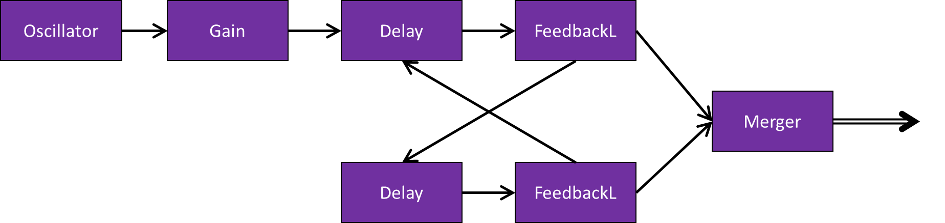
Figure 15.3. Block diagram of ping pong delay.
<button id='ping'>Ping</button>
<script>
ping.onclick = function() {
context.resume()
BurstGain.gain.value=1
BurstGain.gain.linearRampToValueAtTime(0,context.currentTime + 0.040)
}
var context= new AudioContext()
Burst=new OscillatorNode(context)
BurstGain=new GainNode(context,{gain:0})
Burst.start()
Burst.connect(BurstGain)
var merger = context.createChannelMerger(2)
var leftDelay = new DelayNode(context,{delayTime:0.5})
var rightDelay = new DelayNode(context,{delayTime:0.5})
var leftFeedback = new GainNode(context,{gain:0.8})
var rightFeedback = new GainNode(context,{gain:0.8})
BurstGain.connect(leftDelay)
// Connect the routing - left bounces to right, right bounces to left.
leftDelay.connect(leftFeedback)
leftFeedback.connect(rightDelay)
rightDelay.connect(rightFeedback)
rightFeedback.connect(leftDelay)
// Merge the two delay channels into stereo L/R
leftFeedback.connect(merger, 0, 0)
rightFeedback.connect(merger, 0, 1)
// Now connect 'merger' to the output destination.
merger.connect(context.destination)
</script>

Code example 15.2. Ping pong delay using the ChannelMergerNode.

